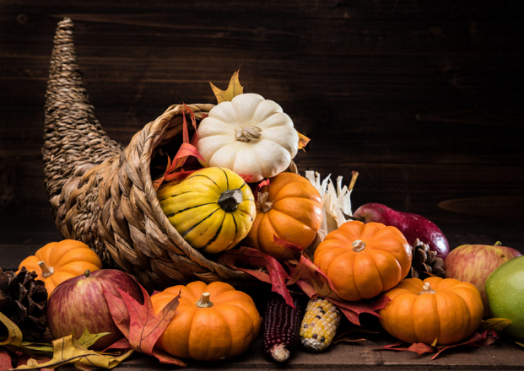
This Photo by Unknown Author is licensed under CC BY-NC-ND

Dear Friends,

“The grace of our Lord Jesus Christ, and the love of God, and the fellowship of the Holy Spirit be with you this Thanksgiving.”

Some of the most important questions each of us can ask during this season are, “What are my priorities for this Thanksgiving weekend? With whom do I want to spend time? How would I prefer to celebrate? Do my celebrations include worship, a meal and a conversation? Who are the top ten people I want to spend time with this weekend?” All of these priorities are important and all of these decisions are yours alone. Whatever your decision might be, let me encourage you to be intentional with a plan that suits your needs this Thanksgiving. It’s really healthy to respond to new situations with new responses.

Most of us appreciate our health when it’s good but don’t necessarily spend a lot of time talking about it until it’s bad. You may have heard someone say, “I’m feeling lousy, or I’m having a rough time lately and spending a lot of time with my doctor.” But I have a friend who is a cancer survivor. Now when you enquire, “How are you?”, his response is, “I’m healthy”. You can imagine his smile as well as his internal relief and gratitude that he can actually say, “I’m healthy”. Most of us don’t want to attract a lot of attention to ourselves, so we simply say, “I’m fine”. The point is it’s important to celebrate good health and be grateful to God for our doctors, nurses, nurse practitioners and surgeons, all of whom contribute to us getting healthy. An attitude of gratitude goes a long way for our physical, spiritual and psychological health.

Statistics suggest that if we have three or four best friends in a lifetime, we are truly blessed and need to be grateful for their presence in our lives. Furthermore, we need to express our gratitude to them. Words really matter. Occasionally we assume that these extraordinary people will always be there. Not true. We have all lost several close friends to cancer, heart attacks and more unbelievable situations and circumstances than can even be described here. As you know, these losses are real and sometimes devastating. I have always been grateful that there have been opportunities to tell most of these people how much I appreciated them before they died. An attitude of gratitude is so important. Especially when it come to telling the people we love how important they are in our lives.

Thanksgiving gives us the opportunity to gather with family and/or friends to enjoy some good food and get time to share laughter, stories, experiences, and precious moments together. As I look back over the years, I wish I had taken the risk of telling everyone in the room that I appreciated them. I got to speak to most of them but it’s always the one you are convinced you will see again soon, who dies and you never get that opportunity again. The life lesson is to embrace everyone who permits it. Speak words of affection and respect and never leave a room without telling everyone how grateful you are for the relationship.

I believe that each one of us needs to be profoundly grateful for all the bounty and blessings that we have received during our lifetime. I believe that this is a time to be grateful to God for our lives and for all the opportunities that He has given us, especially in the last few years. I believe that this is the time to give thanks to our Lord for the salvation provided through Jesus Christ. I believe that we should express that appreciation to Him in prayer every day. So this coming Thanksgiving Day, let me encourage you to send a few emails, write a few cards, type a few texts, make a few calls and say a few prayers. Let me encourage you to sit quietly and listen to the beauty of your favourite music. Perhaps you will even eat some of your favourite foods and enjoy your favourite people. All these people and things are God’s blessing in your life.

As we approach the Thanksgiving season, we may do so with some trepidation because we are keenly aware that this year may be different from previous years. Perhaps your health situation has changed or perhaps family are unavailable to get together this year. There is even a chance that you are so exhausted that you are not sure whether or not you have the energy or enthusiasm to engage a large group of people. May I suggest that you be very gentle with yourself during the festive season? The intent of Thanksgiving is not that you push yourself so far that you are disappointed or frustrated by the experience. But rather that you have made some healthy personal choices about where you go and who you are with. Your physical, emotional and spiritual health are a priority during the Thanksgiving season.

Our Lord Jesus Christ lived with an attitude of gratitude. There are many examples in scripture when he paused to pray to give thanks to God for the many blessings that have been bestowed on Him and the people that He came to offer hope and salvation. Jesus spent a lot of time investing healthy attitudes into his disciples. His teachings were filled with hope, joy, love, forgiveness and gratitude. You and I are invited to model His example. It begins with giving thanks to God every time you wake up. It continues through the day when you intentionally search for moments give thanks for the beauty of creation and for the people who love you and support you.

May I take this opportunity to invite you to join us for worship on Thanksgiving Sunday at either 8:15 am or 10:00am? We will be celebrating Holy Communion and praising God through music and liturgy and prayer for all the blessings that He has given us. I want to warmly invite you to share in that worship experience.

“The Lord bless you and keep. The Lord make His face to shine on you and be gracious to you. The Lord look upon you with favour and grant you peace.”

Blessings

The Rev Canon Dr Stephen Hendry

